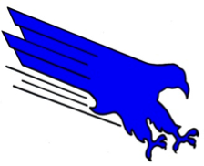

***Ensure High Levels of Academic Achievement***

To Whom It May Concern,

I’m writing this text as a placeholder for our new letterhead. This version is more of a marketing-type letterhead as it includes our district vision. Sending something home to parents? Sending something to CDE? Use this version of the letterhead.

The first and subsequent pages on this version of the letterhead are identical.

The font used here as the default is Arial, one of our two font families for the District 49 brand. The font size selected for the default is 12pt, but others may be used as necessary.

The second font family is Adobe Garamond Pro and is used for the “D1str1ct” in the logo and for the address, website and phone numbers below.

When creating a document, standard usage of the font families is:

Adobe Garamond Pro for titles and section headers.

Arial for main text bodies.

These rules are not hard and fast in our brand, if you’d like to use the serif font (Adobe Garamond Pro) for the main text bodies and the sans serif font (Arial) for the titles and headers, you may do so.

You can learn more about the District 49 brand, including logo usage, colors, school names, etc. on D49.org/logo.

Best,

Matt Meister

Director of Communications

