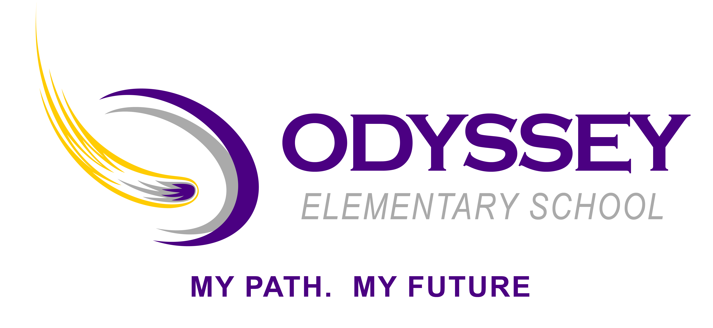

**For more information visit D49.org/OES**

* **School Info**
* **Classes & Activities**
* **Student Services**
* **Parents & Community**
* **Leadership**

Odyssey Elementary School is dedicated to creating experiences that develop character and purpose though daily personalized learning opportunities that are second to none. To further this approach, students will have choice in how they engage, with options in methods, tools, and ways of demonstrating learning based on preference and need. Personalization will be enhanced through regular collaborative, experiential activities that utilize integrated through technologies.

**PROGRAM TITLE**